**Project -1**

**Software installations**



**Name: Nikhil Reddy Gundeti**

**Tutor: Raham Shaik**

**Batch: June 2022**

**Steps:**

**Java installation on ubuntu**

The following are the commands I ran to install java on ubuntu

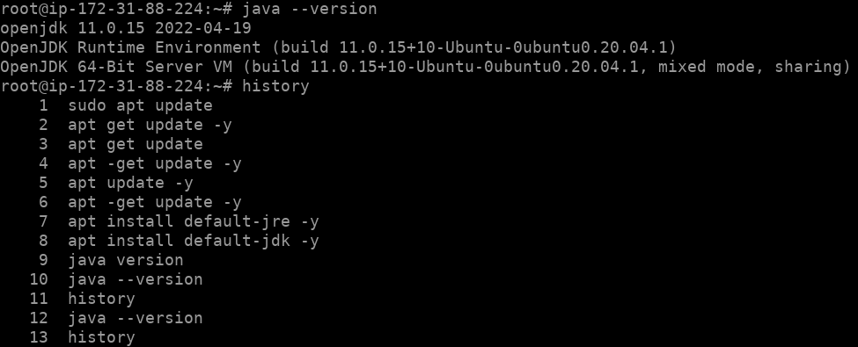

Then ran a basic java program using cat command as shown below

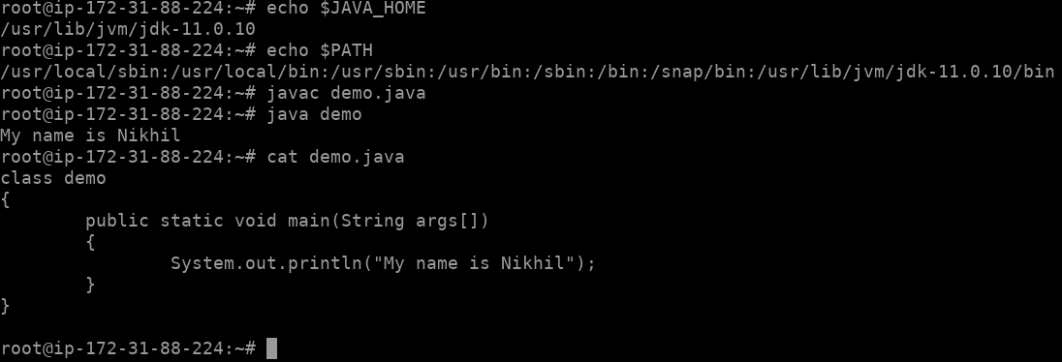

**Python installations on ubuntu**

Using apt install python3.8 python3 -y

Installed python and ran a basic python program as shown below

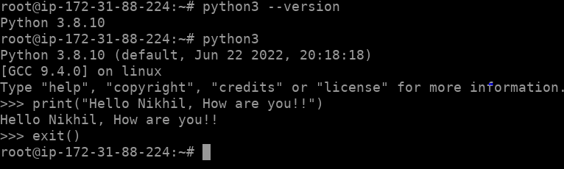

**Nodejs installation on ubuntu**

Installed and ran a basic command using nodejs

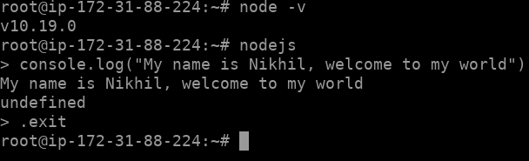

**ArangoDB installation on ubuntu**

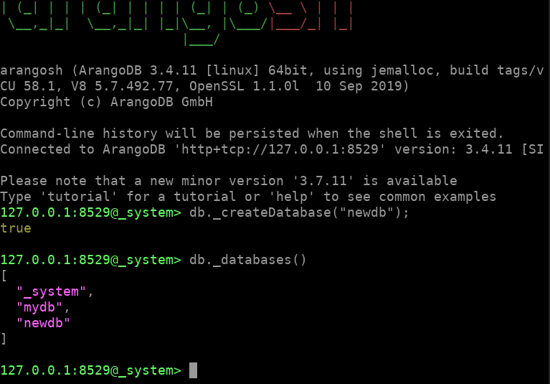

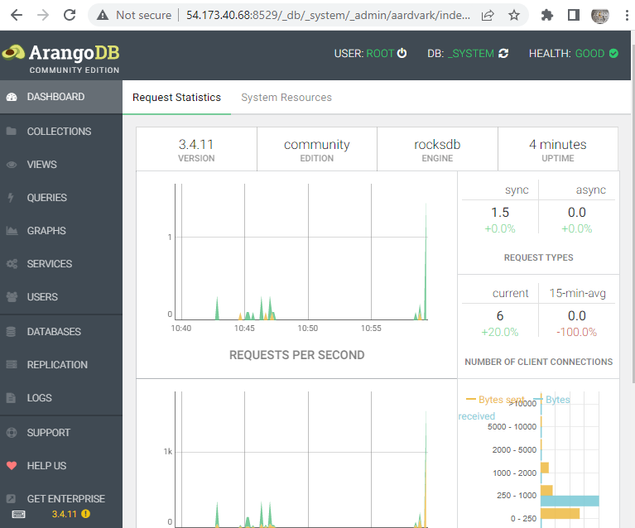

**PERCONA MYSQL installation on ubuntu**

